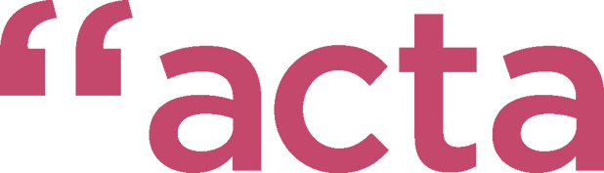
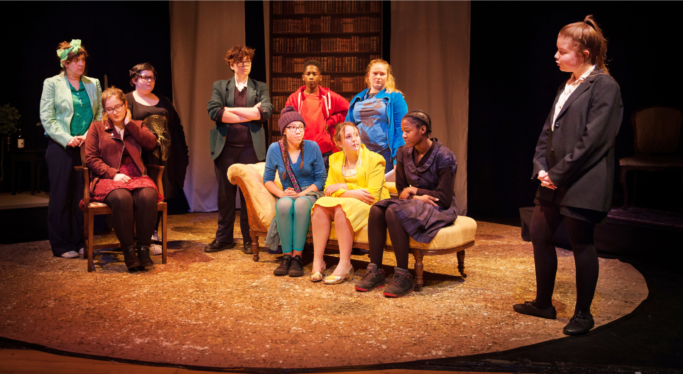
Trustee recruitment pack Summer 2023
What is this pack for?
We're looking to grow our board - we're looking for trustees with experience in HR, legal, arts and culture, corporate fundraising and environmental sustainability.
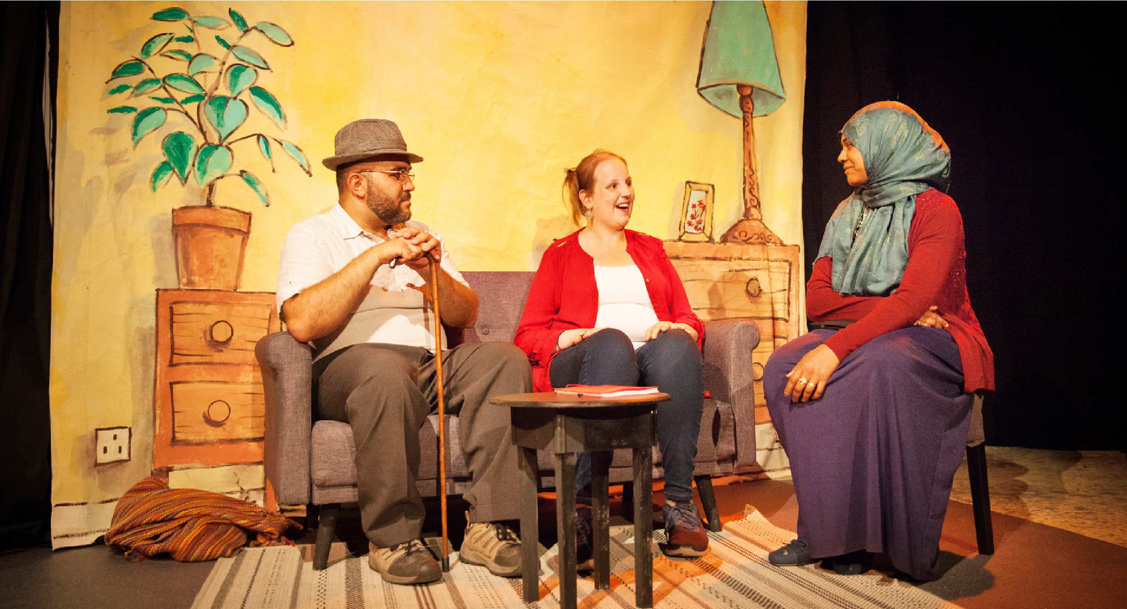
Over the years, we've been really lucky to work with people from all different backgrounds so we're looking to recruit people who can reflect this, and bring that all important perspective.
We're also going through a period of change at the moment with fluctuating needs of the community, and funders, we are looking at a period of transformation. We want people to join our board who can help us steer us on this journey, and keep us on track. It's an exciting time to join the acta team.

What is acta?
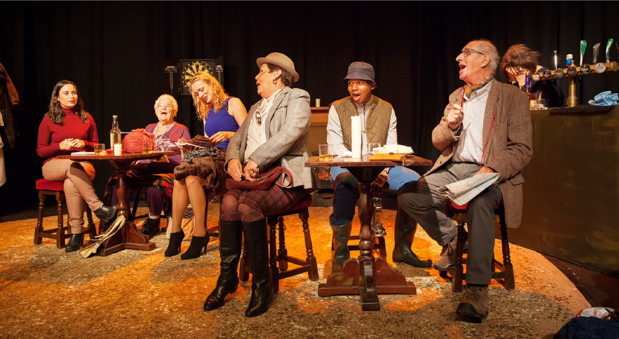
Since 1985, we have been working to bring together people from different cultures, experiences, and generations to make and share creative work. To do this we run several different regular open access creative groups, often with a focus on theatre, in Bedminster and beyond. We believe creativity belongs to everyone, and everyone has a story to tell. acta is a place where everyone’s story matters, where individual opinions and experiences count, and are valued by others. We enable communities to share their stories, and engage audiences who rarely attend theatre.

We have a theatre in Bedminster from where we currently run nine of our thirteen weekly creative groups. For the other four (in Lockleaze) we travel to them. In our building we also have a café, currently used for refreshments during shows but also a weekly hot meal for local older people, helping alleviate social isolation. On Thursdays, we open it as a Creative Wellbeing Café.

What you'd do
Trustees are central to the ongoing success of acta, being responsible for the overall direction, strategy and vision of the charity.
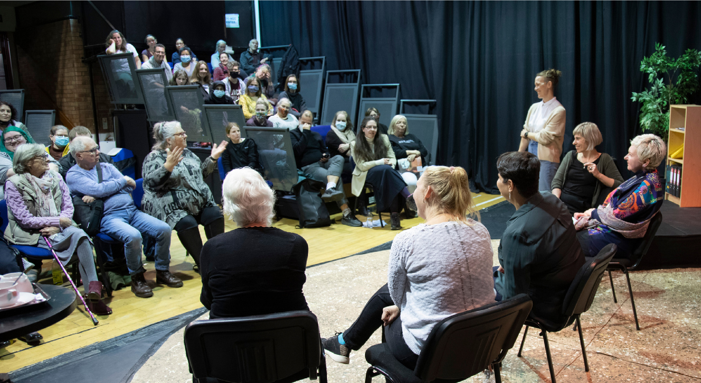
This is a voluntary position, and we would ask you to join us for a minimum of 6 x 2hr meetings a year with some additional commitment to working with the acta staff and trustees through sub-committees and informal conversations.
We'd also love it if you could attend our shows and events, and we'd hope you would act as an ambassador for acta where possible.
You can learn more about our current board and our staff team here: Who We Are (opens in a browser)

What to do now
If you like what you've read, and you think you can help us in our vision to change lives through community theatre then we'd love to hear from you.
You can get in touch with us and tell us who you are and what you could bring to acta. We're open to receiving this in various formats - we know that written communication isn't for everyone. You could:
send us an email or letter record a short video or audio file create a portfolio of your skills and experiences anything else you can think of!
We just ask that it can be something we can review in our own time, revisit, and takes less than five minutes to read, watch, listen to, etc.
The next steps will involve an informal discussion with one of our board members, or our Director, Oliver Jones, and we'll invite you to observe a board meeting.
There is no deadline for this opportunity, we will consider each application until we have a full board.
We very much look forward to hearing from you. Please see below for contact information and do get in touch if you have any questions.
To apply:
Email | oliver@acta-bristol.com
Call us | 0117 953 2448
Social media | Twitter and Instagram @actatheatre
Facebook @actacommunitytheatre
Postal address | acta, Gladstone St, Bedminster, BS3 3AY

